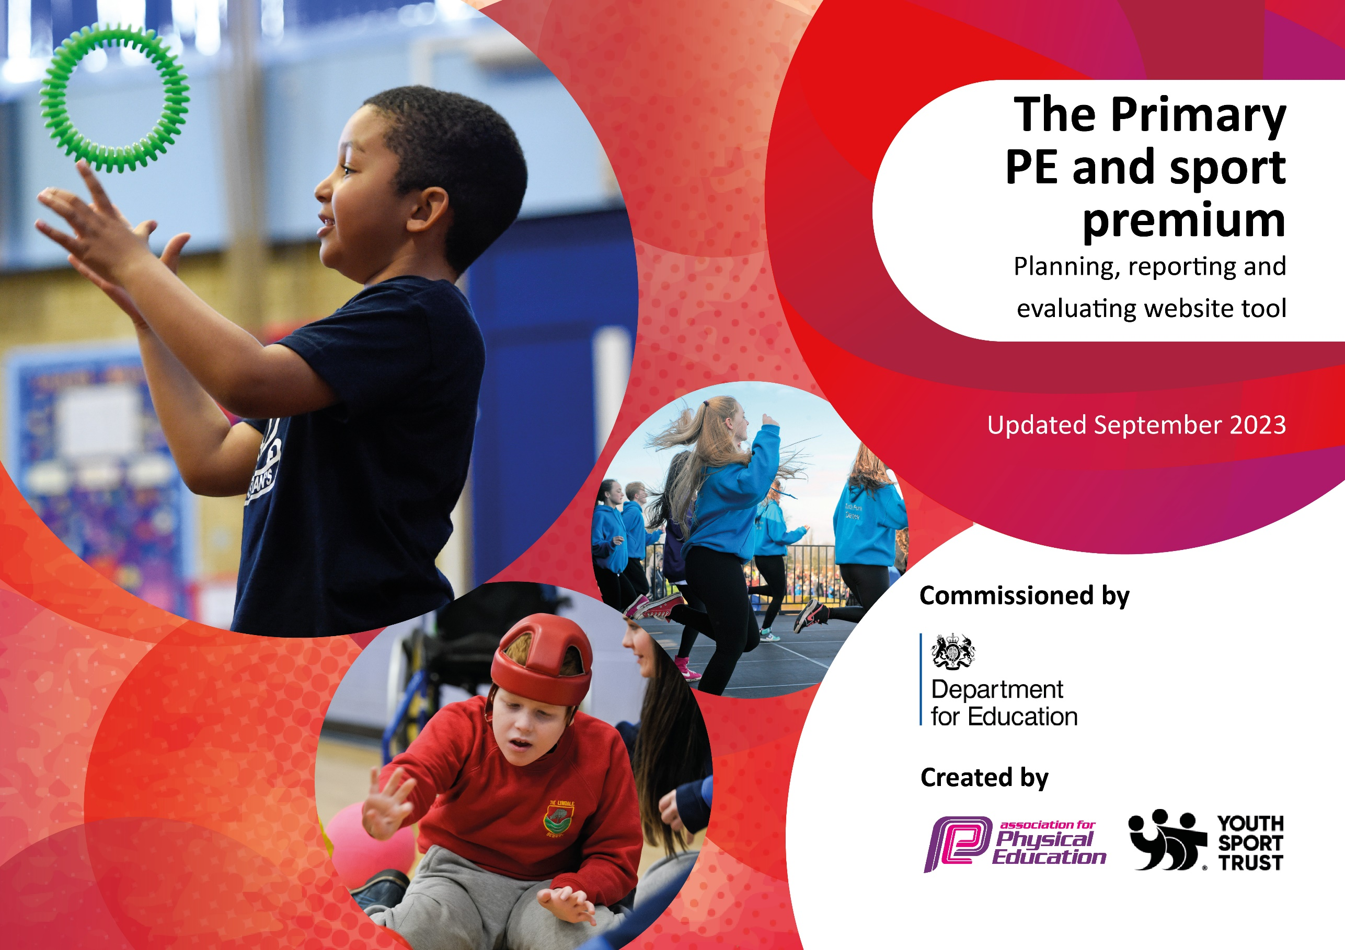

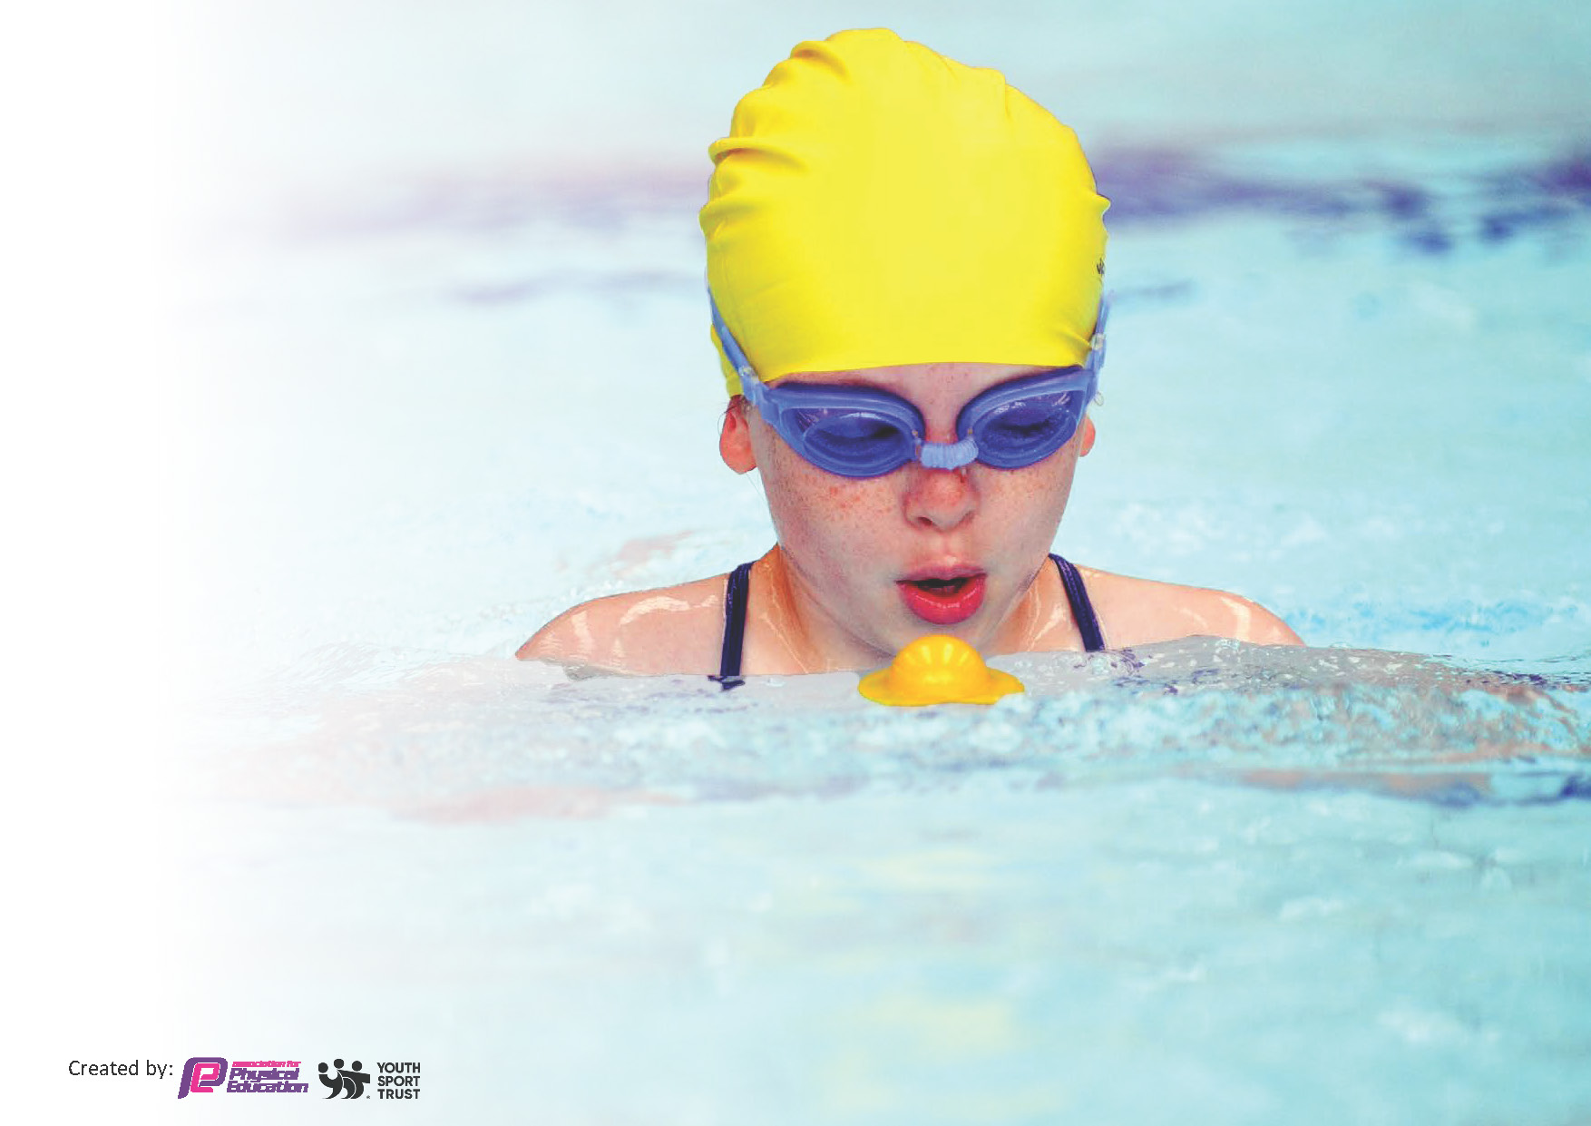
This template can be used for multiple purposes:
by:
- It enables schools to effectively plan their use of the Primary PE and sport premium
- It helps schools to meet the requirements (as set out in guidance) to publish information on their Primary PE and sport premium
- It will be an effective document to support Ofsted inspections enabling schools to evidence progress in Physical Education (PE) and evidence swimming attainment, which forms part of the PE National Curriculum. We would recommend schools consider
the Intent, Implementation and Impact of any spend, as examined within the Education Inspection Framework.

It is important that your grant is used effectively and based on school need.

Schools must use the funding to make additional and sustainable
improvements to the quality of the PE, School Sport and Physical Activity (PESSPA)
they offer. This means that you should use the Primary PE and sport premium to:

- Build capacity and capability within the school to ensure that improvements made now will benefit pupils joining the school in future years
- Develop or add to the PESSPA activities that your school already offers.

The Primary PE and sport premium should not be used to fund capital spend projects; the school’s core budget should fund these. Further detail on capital expenditure can be found in the updated Primary PE and sport premium guidance.

The Primary PE and sport premium guidance, outlines 5 key priorities that funding should be used towards. It is not

necessary that spending has to meet all the key priorities, you should select the priorities that you aim to use any funding towards.

Although completing this template is not a requirement for schools, schools are required to publish details of how they spend this funding. Schools must also outline what the impact this funding has had on pupils’ PE and sport participation and attainment and how any spending will be sustainable in the future. All funding must be spent by 31st July 2024.

The Department for Education has worked closely with the Association for Physical Education (afPE) and the Youth Sport Trust (YST) to develop this template and encourages schools to use it. This template is an effective way of meeting the reporting requirements of the Primary PE and sport premium.
Review of last year’s spend and key achievements (2022/2023)

We recommend you start by reflecting on the impact of current provision and reviewing your previous spend.

Activity/Action | Impact | Comments
Please see 2022/23 documentation for the full review of the previous spend with some key issues raised here.  What went well:  Our new equipment enhanced the delivery of our PE delivery and playtime opportunities.  Our SSP membership provided us with CPD, competitions and pupil training.  What we need to improve  Swimming pass rate was very low at 43%. | Our sports crew is providing opportunities for pupils to experience a range of activities at break times. | New sports crew club to run for the Autumn term 1.  Review current practice. Look into swimming for schools. Hosting a swimming pool at our school for two weeks to provide targeted intervention.

Key priorities and Planning
This planning template will allow schools to accurately plan their spending.

Action – what are you planning to do | Who does this action impact? | Key indicator to meet | Impacts and how sustainability will be achieved? | Cost linked to the action
Swimming top -up using ‘pools for schools’ to target non-swimmers in KS2.  Use data and assessment to support targeting pupils. | KS2 pupils who cannot swim or who are not on track for the end of year requirements. Only 25% of current year 6 were able to complete 25m last year in year 5.  Opportunities to be provided for KS1 pupils to swim in after school clubs. | Key indicator 2 – increase engagement of all pupils in physical activity.  Key indicator 4 – Broader and more equal experience of a range of sports and physical activities offered to all pupils. | If this program is successful then it will be implemented every year with more pupils meeting the end of key stage requirements for swimming. | 6/7 of the pool and staff hire plus costings for electricity and water.  £4,285
Review, replenish and replace equipment for PE and playtime games.  Use this equipment to create ‘My Personal Best’ targets for pupils of all ages. | All pupil’s engagement in physical activity. Use pupil voice and the sports crew to gather preferences for games equipment. | Key indicator 2 – increase engagement of all pupils in physical activity.  Key indicator 3 – the profile of PE and sport is raised across the school as a tool for whole school improvement.  Key indicator 4 – Broader and more equal experience of a range of sports and physical activities offered to all pupils. | This will support more pupils meeting their daily physical activity goal and encourage more pupils to take part in PE and sport activities. | £2,500 budget.
Quidditch experience day and equipment purchase – whole school investment into a new sport for PE lessons and extra-curricular clubs. | Teaching staff, all pupils including less active pupils. Targeted clubs for FSM and less active pupils.  Take part in competitions with other schools in our area who are trained in Quidditch. | Key indicator 1 – Increase confidence, knowledge, and skills of all staff in teaching PE and sport.  Key indicator 2 – increase engagement of all pupils in physical activity.  Key indicator 4 – Broader and more equal experience of a range of sports and physical activities offered to all pupils.  Key indicator 5 – Increased participation in competitive sport. | This investment would see a long-term impact of inclusive sport, competitive sport and staff being trained in a new sport. | Equipment £1,200  Experience day and coaching - £600
Well-being days.  2/3 days off timetable where well-being is through physical exercise is the driver. A range of sports, coaches, new experiences to encourage physical and mental well-being. | All pupils, staff and parents to participate. Pupil voice to support choices of activities. | Key indicator 2 – increase engagement of all pupils in physical activity.  Key indicator 3 – The profile of PE and sport is raised across the school as a tool for whole school improvement.  Key indicator 4 – Broader and more equal experience of a range of sports and physical activities offered to all pupils. | This would become an annual event which would providing a lasting legacy of sport and mental well-being at Rossmore school. | Coaches, equipment and other costs associated:  £2,500.
Sports day | All staff, pupils and parents. | Key indicator 2 – increase engagement of all pupils in physical activity.  Key indicator 3 – The profile of PE and sport is raised across the school as a tool for whole school improvement. | Our sports day has always been successful and well supported. This will continue this opportunity for all stakeholders. | £300 – equipment, prizes and other costs.
Teach active to promote physical activity in maths and English lessons. | All pupils as they will take part in physical activity during traditionally class-based lessons. | Key indicator 1 – Increase confidence, knowledge, and skills of all staff in teaching PE and sport.  Key indicator 2 – increase engagement of all pupils in physical activity. | More pupils meeting their daily physical activity goal. | Renewal cost:  £1,275
Membership of the School Sports Partnership (SSP) to provide CPD, competitions, wider sporting opportunities and much more. | All staff and pupils. | Key indicator 1 – Increase confidence, knowledge, and skills of all staff in teaching PE and sport.  Key indicator 2 – increase engagement of all pupils in physical activity.  Key indicator 3 – The profile of PE and sport is raised across the school as a tool for whole school improvement.  Key indicator 4 – Broader and more equal experience of a range of sports and physical activities offered to all pupils.  Key indicator 5 – Increased participation in competitive sport. | Ongoing membership which has provided our staff/pupils with training which is then implemented into school providing opportunities for all. | £1,300
Pupil voice informed extra-curricular clubs. | Staff and pupils who lead and participate in the clubs.  SEND/ disadvantaged pupils/ less active/ female pupils targeted for certain clubs. | Key indicator 2 – increase engagement of all pupils in physical activity.  Key indicator 3 – The profile of PE and sport is raised across the school as a tool for whole school improvement.  Key indicator 4 – Broader and more equal experience of a range of sports and physical activities offered to all pupils. | Pupils will experience sports which will lead to lifelong opportunities and love of sport. | TA wages  1 ½ hours a week for 35 weeks at approximately £600 per staff member.  X 3 = £1,800
Complete PE teaching resource | Staff confidence in teaching a broad and balanced PE curriculum.  Pupils receive 2 hours high quality PE a week. | Key indicator 1 – Increase confidence, knowledge, and skills of all staff in teaching PE and sport.  Key indicator 2 – increase engagement of all pupils in physical activity.  Key indicator 4 – Broader and more equal experience of a range of sports and physical activities offered to all pupils. | Complete has provided higher quality PE lessons at Rossmore for several years now. | £175

Supply teacher cover to allow staff the opportunity to attend CPD and sporting fixtures with pupils. | Teachers and Tas gaining knowledge of the curriculum, individual sports training and games rules.  Pupils given the opportunity to attend a wider and larger range of events. | Key indicator 1 – Increase confidence, knowledge, and skills of all staff in teaching PE and sport.  Key indicator 2 – increase engagement of all pupils in physical activity.  Key indicator 4 – Broader and more equal experience of a range of sports and physical activities offered to all pupils.  Key indicator 5 – Increased participation in competitive sport. | Staff knowledge for higher quality teaching of PE at school.  Pupils’ confidence and self-esteem. | 1 afternoon’s supply cover at approximately £100 x 27 events = £2,700
 |  |  |  | Total spend: £18,635

Key achievements 2023-2024
This template will be completed at the end of the academic year and will showcase the key achievements schools have made with their Primary PE and sport premium spending.

Activity/Action | Impact | Comments

Swimming Data
Meeting National Curriculum requirements for swimming and water safety.
Priority should always be given to ensuring that pupils can perform safe self-rescue even if they do not fully meet the first two requirements of the National Curriculum programme of study

Question | Stats: | Further context  Relative to local challenges
What percentage of your current Year 6 cohort can swim competently, confidently and proficiently over a distance of at least 25 metres? | 25% | These were our strong top group swimmers in year 5. We had other children who could swim in year 5 but we didn’t feel were quite confident enough in completing 25m yet.
What percentage of your current Year 6 cohort can use a range of strokes effectively [for example, front crawl, backstroke, and breaststroke]? | 25% | As above. We had a strong top group at swimming who swam all of the strokes confidently and a number of other children who were good swimmers but need some more work on the effectiveness of their strokes.

What percentage of your current Year 6 cohort are able to perform safe self-rescue in different water-based situations? | 75% | Most pupils were able to exit the pool safely and were strong enough swimmers to do this.
If your schools swimming data is below national expectation, you can choose to use the Primary PE and sport premium to provide additional top-up sessions for those pupils that did not meet National Curriculum  requirements after the completion of core lessons. Have you done this? | Yes/No
Have you provided CPD to improve the knowledge and confidence of staff to be able to teach swimming and water safety? | Yes/No

Signed off by:

Head Teacher: | Sue- Davis McCoy
Subject Leader or the individual responsible for the Primary PE and sport premium: | Tom Podmore – PE Lead
Governor: | Mark Poole
Date: | 12th October 2023

