Dear Parent / Carer

Please see the information below as advised from the public health team.
We are writing to provide you with a summary of the latest national COVID-19 advice in place from the 24th February 2022. We have now entered a new phase of learning to live with the COVID-19 virus, and our priority is to support the delivery of resilient face-to-face teaching.
As teachers and parents we should still be alert to the three core COVID-19 symptoms so we can make the best choices for our schools and families.
COVID-19 symptoms and what to do if your child has them
The main symptoms of COVID-19 are the recent onset of:
- a new continuous cough and/or
- high temperature and/or
- a loss of, or change in, normal sense of taste or smell (anosmia)

If your child develops any of these symptoms, then arrangements should be made for them to take a PCR test as soon as possible. Your child should stay at home and avoid contact with others while awaiting the PCR test result. Please note that we are also sending students home if we believe they have one or more symptoms requiring a PCR test.
Testing for pupils with symptoms can be arranged by calling 119 or via the NHS website: www.nhs.uk/coronavirus. Please keep us informed of the results of any tests.
So long as their PCR test result is negative, your child/children can continue to attend school as usual, if they have no symptoms.
If any test results are positive, your child/children should stay at home and avoid contact with other people. Please see the diagram below for further information on safely returning to their normal routine.

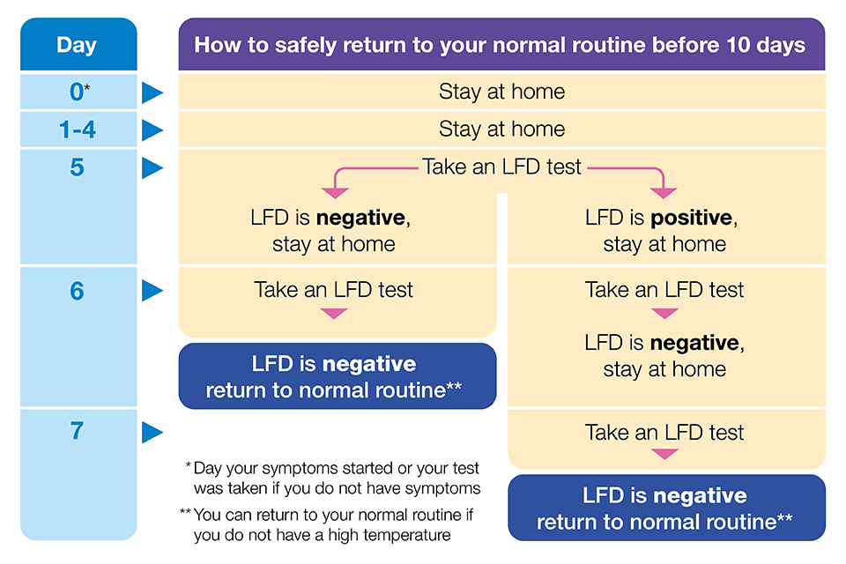

What to do if your child is generally unwell
If your child is unwell with general symptoms such as a sore throat, runny nose, and/or headache/muscles aches, they should not attend school to avoid spreading infection within the school. We may send students home if we believe they present a risk of infection to other students.

Pupils who are in the same household as a symptomatic or positive case (e.g. siblings)
If an individual in a household tests positive or has symptoms, any children and young people in that household who attend school or college should:
- Attend their education or childcare setting as normal
- Minimise contact with the person who has COVID-19 at home
- Avoid contact with anyone you know who is at higher risk of becoming severely unwell if they are infected with COVID-19, especially those with a severely weakened immune system.
- Pay close attention to the main symptoms of COVID-19. If they develop any of these symptoms, seek a PCR test. They are advised to stay at home and avoid contact with other people while waiting for the test result.

Changes in line with government ‘Living with COVID-19’ plan
- No-one is legally required to self-isolate if they test positive for COVID-19. They are advised to stay at home and avoid contact with other people.
- Regular asymptomatic LFD testing is no longer recommended.
- Unvaccinated individuals are not legally required to self-isolate following contact with someone who has tested positive for COVID-19.
- Individuals can still take an LFD test from day 5 after symptoms started (or the day you had the test if you do not have symptoms) and 24 hours after that. If these tests are both negative, individuals can return to their normal routine before 10 days.
- Contact tracing conducted by NHS Test and Trace has been discontinued.

Thank you for your continued support and please rest assured that we will continue to monitor the situation carefully and to be guided by the advice of our local Public Health Team.

Yours Sincerely,
