

**WEEKLY NEWSLETTER**

**Date: 11th March 2022**

Telephone No: 0151 329 3688

www.rossmore.cheshire.sch.uk

Dear Parents/Carers

**COVID UPDATE** There have been confirmed cases of Covid-19 in School. We are monitoring this closely. This week all the children went home with letters regarding the most up to date Covid-19 guidance. We ask that all our parents/carers are vigilant in regards to symptoms and follow our guidance accordingly. You will also find this information on our School website.

**THIS WEEK IN SCHOOL**

* Year 2 are having a Dance Festival at the civic hall it is being held on Thursday 17th March. This is a ticket event only, which you should already have.
* There is a netball event for a few of our children from across Ks2 being held at the North Gate Arena – Good luck to everyone involved.

   

**PTA** Thank you for the response in joining our PTA. In order for future events to go ahead we still need more parents to join our PTA to help with the planning and organising stages. Upcoming events include; discos, bingo and the summer fair. Through fundraising the PTA have been able to purchase items including; games for wet playtimes, magazine subscriptions and books for our school library, table tennis tables, outdoor play equipment and computing equipment. Without this valuable fundraising we simply wouldn’t be able to afford these items which benefit children now and for years to come. If you would like to join our PTA, or are even able to help out every now and then, please inform the school office

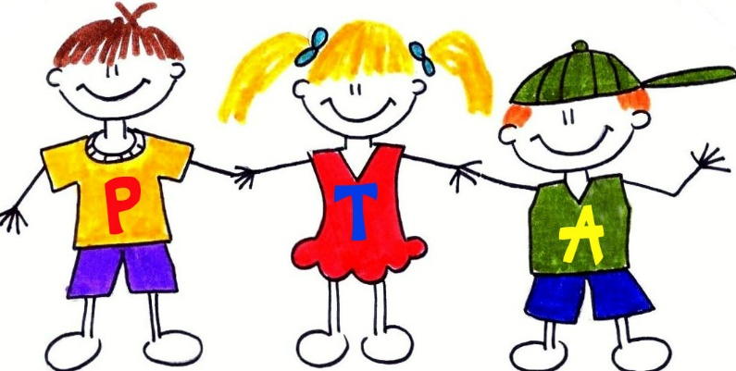

**SCHOOL ABSENCE LINE** If you are reporting a child’s absence, please only do this via our school absence telephone line. This is the most efficient way of reporting an absence and ensuring things are not missed. Even if your call is unanswered messages can be left 0151 329 3688.

**PARENTS EVENING** Please all be aware that our parents evening slots will be going out via School Spider next week. We are delighted to inform you that this will be a face to face event in the school hall. We encourage you to bring your child with you to this meeting as we like to involve them as much as possible within the appointment. Please also note Monday and Tuesday after school clubs will **not** be running due to parents evening.

**SCHOOL BUS** Just a few reminders about the school bus service:

* If your child does not need the bus service on a particular morning you **must** text the bus phone by 8am
* Please be ready and waiting for the bus at your allocated pick up/drop off point, any delays impact on other children waiting for the bus.
* Unfortunately, the bus service is currently full, we will be taking new applications for next year during the summer term.

**ART IN SCHOOL** Miss Lloyd has asked if anyone is able to or would like to donate to the School some Art aprons or Large old t-shirts this would be greatly appreciated.

**SICKNESS** If your child is sick and/or has diarrhoea they will need to remain off school for 48hrs from the last bout of sickness/diarrhoea. This is in accordance with the guidance we follow from the Health Protection Agency.

**RESIDENTIAL TRIPS** Please ensure you are on track with your payment plans for these trips. All monies are payable on School Spider. Please note that Year 4 final balance is due at the end of this month. Here is a reminder of all upcoming residential trips:

|  |  |  |  |  |
| --- | --- | --- | --- | --- |
| **Year**  **group** | **Trip** | **Dates** | **Cost** | **Payment deadline** |
| **4** | JCA-  Condover Hall | 27th April 2022 (2nights) | £100 | ~~Deposit: £25 due 31.12.21~~  Final balance: £75 due by 31.03.22 |
| **5&6** | London | 24th May 2022 (3 nights) |  | ~~Deposit: £50 due 31.12.21~~  ~~Payment 1: £50 due 31.01.22~~  ~~Payment 2: £50 due 28.02.22~~  Payment 3: £50 due 31.03.22  Payment 4: £50 due 30.04.22 |

**SPRING TERM ROTAS** Please check through thoroughly and make a note of your child’s class rota.

|  |  |  |  |
| --- | --- | --- | --- |
| **Activity/**  **Day** | **PE** | **FOREST**  **SCHOOL** | **SWIMMING** |
| **Monday** | Year 3  Reception |  | Year 6 |
| **Tuesday** | Year 5  Year 4 |  |  |
| **Wednesday** | Year 3  Year 6  Year 2 |  | Year 1 |
| **Thursday** | Year 4 | Year 2 |  |
| **Friday** | Year 5  Year 1 |  |  |

**WEEKLY ATTENDANCE** Unfortunately due to staff sickness the results from this week's attendance matches will be announced next week. Can Year 6 keep hold of the crown?

**KEY ASSEMBLY DATES** We would like to invite parents/carers/family to their child’s class assembly. This is a great way for the children to share what they have been working on and what they have been learning in School. Please take a note of your child’s class assembly date.

|  |  |  |
| --- | --- | --- |
| **Year Group** | **Key Assembly Dates** | **Time** |
| **Reception** | **Friday 15th July** | **9:15am** |
| **Year 1** | **Friday 1st July** | **9:15am** |
| **Year 2** | **Friday 17th June** | **9:15am** |
| **Year 3** | **Friday 22nd April** | **9:15am** |
| **Year 4** | **Friday 6th May** | **2:30pm** |
| **Year 5** | **Friday 20th May** | **9:15am** |
| **Year 6** | **Friday 30th March** | **9:15am** |

**AFTER SCHOOL CLUBS** Please inform our School office if you no longer want to attend a club, we do have a waiting list for some of our clubs. Unfortunately, due to staff training on Tuesday football club with Mr Podmore is cancelled for next week.

|  |  |  |  |  |
| --- | --- | --- | --- | --- |
| **Day** | **Club** | **Year Group** | **Person in Charge** | **Places available** |
| **Monday** | Science Club | KS2 | Miss Mayhew | **FULL** |
| **Tuesday** | Parliament | Current members only | Miss White | **N/A** |
| Football | 5&6 | Mr Podmore | **(CANCELLED)**  **15th march 2022** |
| Dodgeball | Years 3&4 | Miss Mundy | **FULL** |
| Active Games inspired by Disney Storytelling  *girls only* | Key Stage 1  **lunchtime** | Miss Finlay | **FULL** |
| **Wednesday** | Multi-skills/Games | Year 1&2 | Mr Hutchinson | **FULL** |
| Choir | Current members only | Miss Evans | **N/A** |
| **Thursday** | Active Games inspired by Disney Storytelling  *girls only* | Key Stage 2  **after school** | Miss Finlay | **N/A** |
| Art | KS2 | Miss Lloyd | **FULL** |
| **Friday** | Reading Club  **\*lunch time\*** | KS1 | Miss Edwards | **FULL** |

Please be aware that staff illness absence may lead to some clubs being cancelled. We will endeavour to inform you as soon as possible.

**2022 DIARY DATES**

**Thursday 17th Mar** Dance festival 17.03.22

**Monday 28th Mar** Parents evening

**Tuesday 29th Mar –** Parents evening

**Tue 29th Mar** Year 5 trip to Safety Central

**Thu 31st Mar** Year 6 trip to Safety Central

**Thu 7th Apr** SEND drop in (AM)

Break up for Spring break

**Wed 27th Apr** Year 4- JCA (2 nights)

**Mon 9th May-12th** Year 6 SATS week

**Tue 24th May** Year 5&6- London (3 nights)

Full term dates for this academic year can be found here on our website: <http://www.rossmore.cheshire.sch.uk/serve_file/2547522>

Best Wishes