Reading at Rossmore
A guide for parents
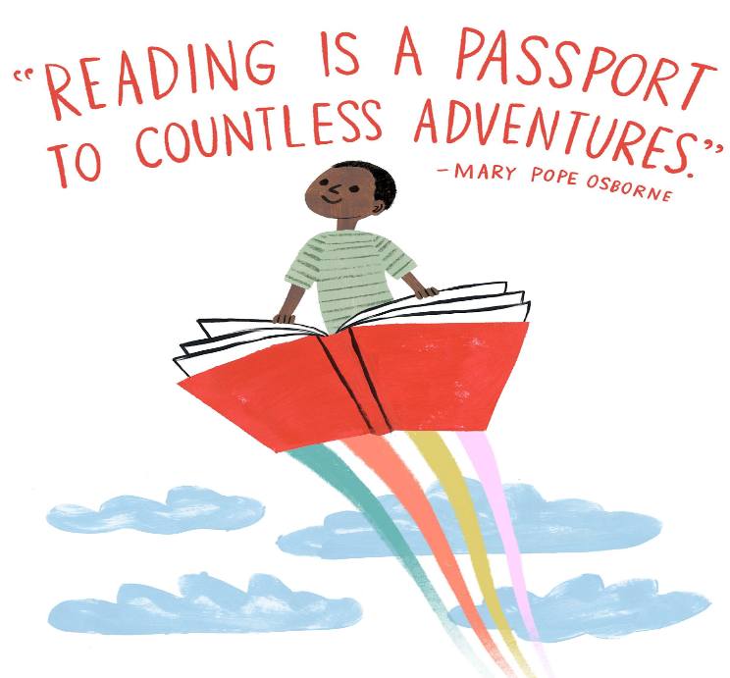

I love listening to stories and I love adventure stories.
Dougie-Year 3
I love reading to my friends.
Elsie-Reception

I like reading in our reading corner.
Harvey-Year 1

I just love books!
Amara-Year 2

Kylan Wheeler
I like reading because it is quiet and I can just read in peace.
Levi-Year 4

Kylan Wheeler

I love everything about reading, it is calming and fun.
Tilah-Year 6
I enjoy quizzing on Accelerated Reader when I have finished my book.
Evie-Year 5
Kylan Wheeler

Teaching Reading in Reception and Key Stage One
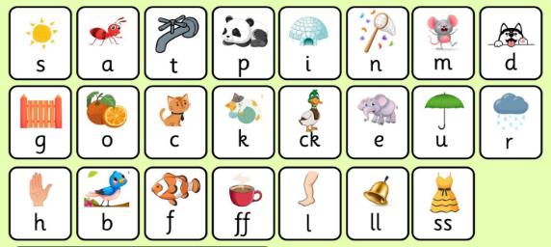
From Reception and throughout Key Stage one we focus on phonics to teach children the skills to decode to read. The children have daily phonics lessons were they learn new letter sounds. All letter sounds have an action to help the children to remember the sounds. They then use the letter sounds they know to sound out words and blend to read. Phonics lays the foundations for all children to read. Alongside phonics, we teach the children to read tricky words. These are words that we can’t always sound out so are therefore tricky.

Shared Reading
At Rossmore we strive to promote a love of reading from an early age. Shared Reading is an important part of how we expose children to high quality literature which is above their reading age. This involves the teacher sharing a range of texts throughout the academic year to introduce children to unfamiliar vocabulary and promote discussion across a wide range of themes.

Guided Reading
We also read with the children in guided groups to develop early reading skills and comprehension. Your child will read with an adult at least once a week and sometimes daily.

DEAR (Drop Everything and Read)
The children have DEAR time daily to give them opportunities to read for pleasure. In Reception and Key Stage one this can involve children sharing books, role play, engaging in a reading activity, reading independently or with an adult.
For children who are accessing Accelerated Reader, DEAR time gives them the opportunity to read and quiz on their books to check their understanding.

Home reading books
Throughout this stage your child will bring home books closely matched to the phonics phase they are working at. This will allow them to practice the skills of decoding words and blending to develop accuracy. We encourage the children to re-read books to develop fluency.
The key to helping your child is listening to them read ‘little and often’. We hope this is a daily activity at home as this will support them to develop fluency. Please sign reading logs after every read or re-read.

In Reception and Key Stage one there will be opportunities for books to be changed two to three times a week. The class teacher will signpost set days books will be changed to allow enough time for children to re-read their books. Teachers will acknowledge reading logs weekly and Guided Reading stamps will be given after your child has read with a member of staff.

Shared reading at home
In Reception the children can borrow story sacks which can be shared with you at home. The story sacks have books, puppets and props to support storytelling to bring books to life!
In Year one and two we hope to build on promoting shared reading at home to instil a love of reading. Your child will bring home a ‘Share with Me’ book chosen by them. This shared text may be a book above their reading age which you can read to them.
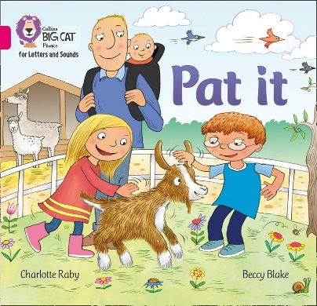
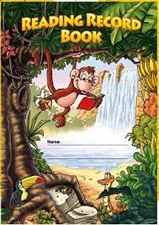

Reading at Key Stage Two
Throughout Key Stage two children continue their reading journey. We still value the importance of phonics particularly in transition to Year three. We teach the children strategies to decode unfamiliar words for example words with prefixes, suffixes, homophones etc. which links spelling and reading. There is a greater emphasis on understanding the meaning of new vocabulary in the context of what children read.

Guided Reading
In lower Key Stage two we still use Guided Reading sessions where needed. During guided group sessions this allows children opportunities to apply reading strategies and further develop comprehension skills.
Shared Reading
As in Key Stage one we continue to promote a love of reading with regular shared reading sessions. Our new ‘Read to Write and Steps to Read’ English units are driven by high quality texts and encourage children to apply new vocabulary and writing structures gained from these texts. Shared reading sessions not only expose all children to high quality texts but we teach a range of comprehension skills from such texts. This gives all children the opportunity to gain a deeper understanding of what they read.

DEAR (Drop Everything and Read)
All year groups have DEAR time daily to allow them time to read for pleasure. In Key Stage two all children are following the Accelerated Reader programme. The children read a book at their level (ZPD range) and once they finish reading a book they take a quiz at school to check their understanding of what they read. When the children have successfully completed a series of quizzes they move up a level progressing at their own rate.

Home reading books
At Key Stage two we greatly value support from home with reading. Although your child may be reading independently it is important to support them by checking their understanding of what they have read.
Ideally reading at home will happen daily to allow children to experience the joy of reading and its ability to take them on many adventures. We value your support and time, please sign your child's reading log when they have read at home. Teachers will acknowledge reading logs weekly and Guided Reading will be signposted after your child has read with a member of staff.
Reading for Pleasure
At Rossmore we want to instil a love of reading throughout the school. All children in Key Stage two can also bring home a ‘reading for pleasure’ book. This could be a book within their ZPD range or another book of their choice from their class library. As this may be slightly above their ZPD range it might give the perfect opportunity to share together at home as a shared text.
