• Recognition board

• Think sheets- to be used when poor choice behaviour is repetitive

• Voice choice cards/lights- signal the level of noise required

• Safe space- is to be used for children to self-regulate using calming down techniques.

Teacher should take time to offer understanding and provide strategies.

**Key information**

• Attitudes to learning- these require consistent reinforcement and correction.

**‘Are the children doing their best?’**

• Perserverance- are the pupils challenging themselves?

**Impositions**

• Payback time lost in learning

• Work to be completed that evening at home and counter-signed by parents and returned the next morning

**End of Breaks**

**Whistle 1-** stop what you’re doing and stand still

**Whistle 2-** put away play equipment and walk to your class line

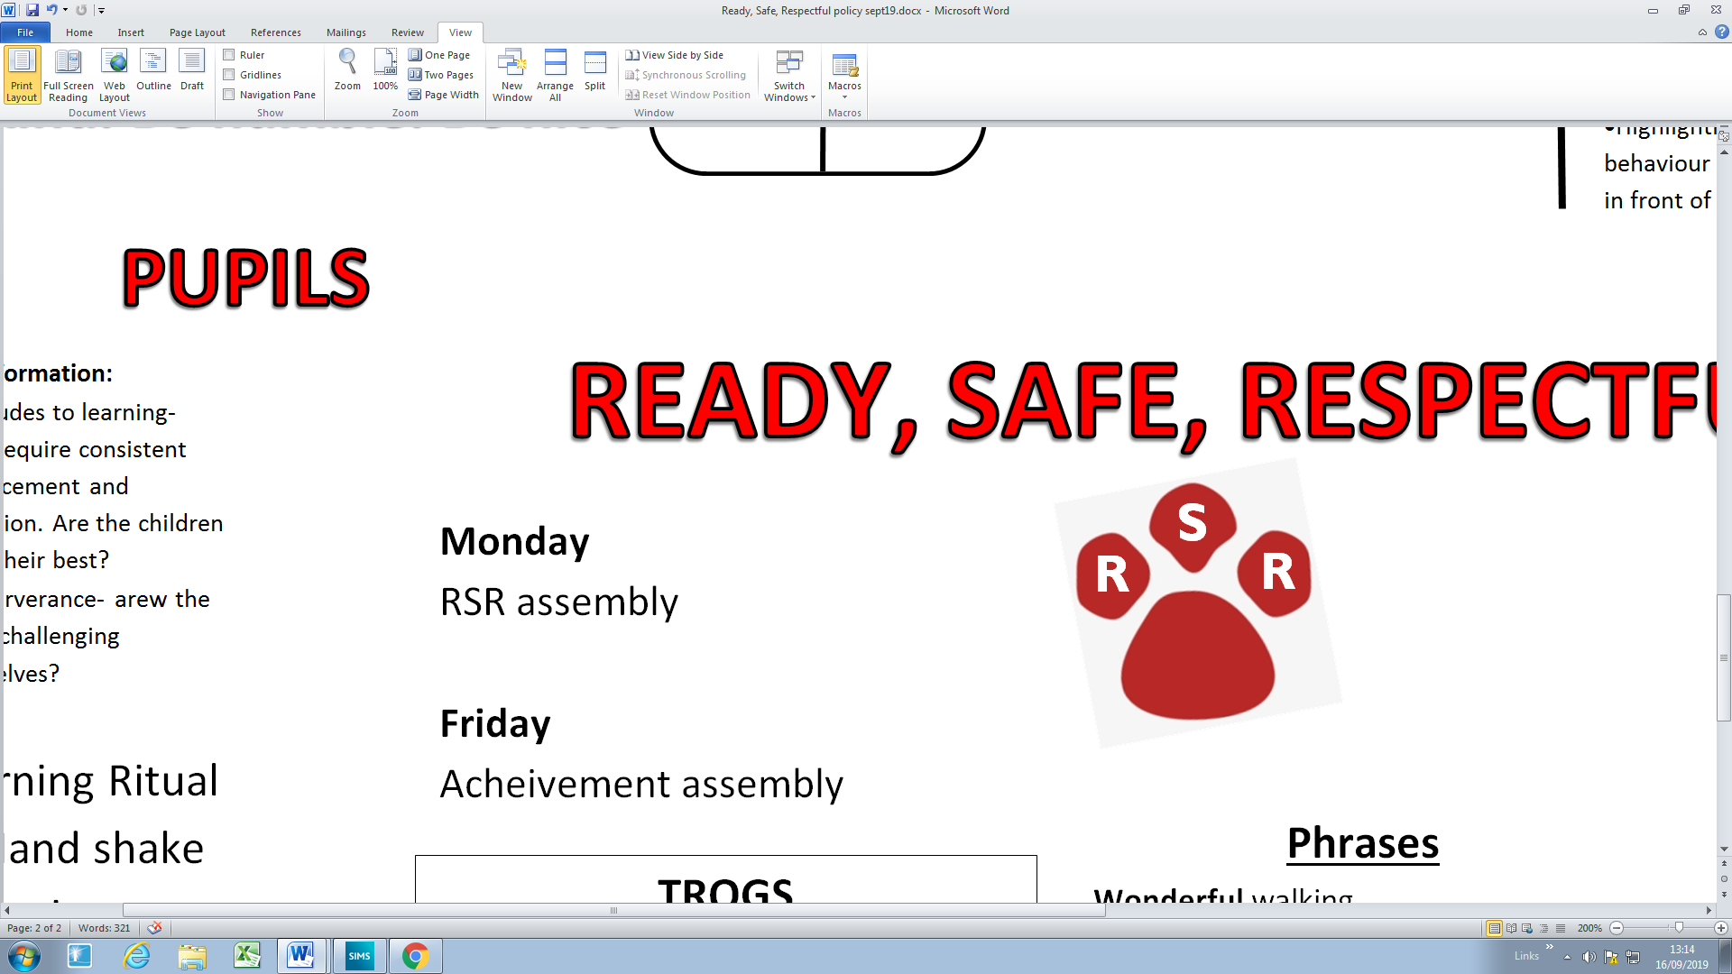

**Morning Ritual**

1- Welcome smile and individual hello.

2- Register

3- R, S, R

**ENVIRONMENT**

**PUPILS**

**Friday**

Whole school acheivement assembly

**READY, SAFE, RESPECTFUL**

**Be kind. Be humble. Be nice.**

**Do’s**  **Don’ts**

• Keep calm •Public shaming- names on board, child stood up,

• Be positive made an example of

• Notice improvement •Children sent to other classes for punishment

•Child sent to another teacher/Headteacher for

punishment

•Showing anger towards a child/ staff member

•Highlighting negative behaviour to other staff in

front of a child

**STAFF**

**Key Information**

•Monitor and support language

• Over emotional responses to inappropriate behaviour will frighten many children

• Children who see shouty, unfair adults as adults who lack control. They are either frightended or find it funny

• Be proportionate

• Persevere

**The Five Pillars of Pivotal Practice:**

1. Consistent, calm adult behaviour
2. First attention to best conduct
3. Relentless routines
4. Scripting difficult interventions
5. Restorative follow up

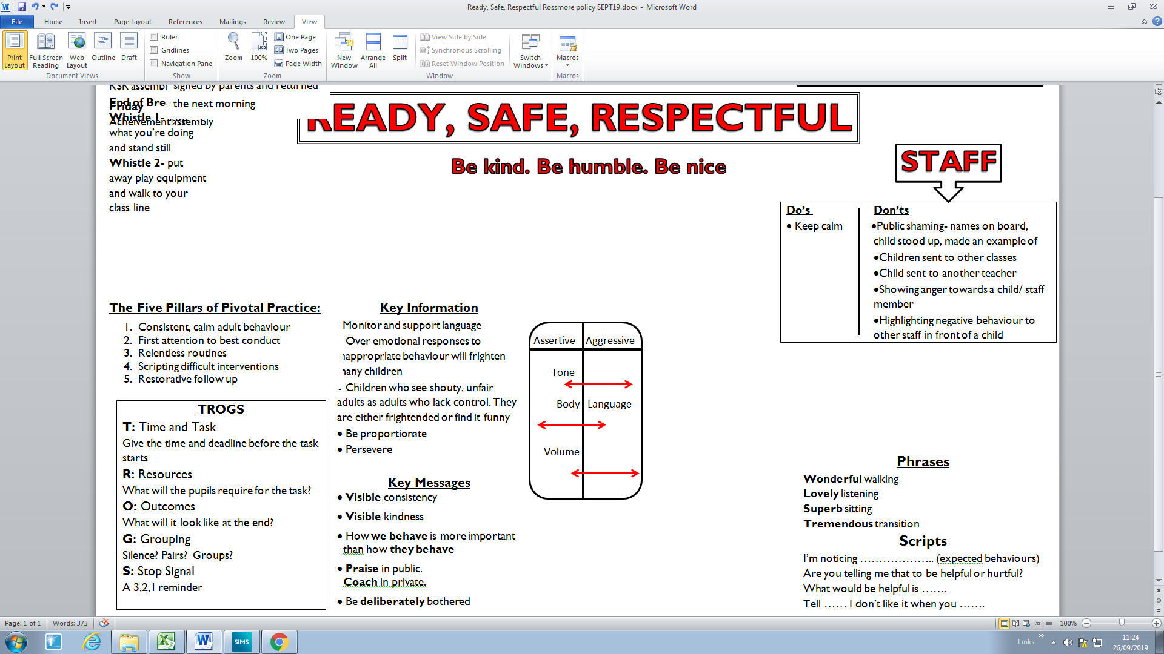

**TROGS**

**T:** Time and Task

Give the time and deadline before the task starts

**R:** Resources

What will the pupils require for the task?

**O:** Outcomes

What will it look like at the end?

**G:** Grouping

Silence? Pairs? Groups?

**S:** Stop Signal

A 3,2,1 reminder, clapping

**Phrases**

**Wonderful** walking

**Lovely** listening

**Superb** sitting

**Tremendous** transition

**Scripts**

I’m noticing ……………….. (expected behaviours)

Are you telling me that to be helpful or hurtful?

What would be helpful is …….

Tell …… I don’t like it when you …….

**Key Messages**

• **Visible** consistency

• **Visible** kindness

• How **we behave** is more important

than how **they behave**

• **Praise** in public.

**Coach** in private.

• Be **deliberately** bothered