5th January 2021

Dear parents/carers

As you will be aware, schools have been asked to close until at least after the February half term. School will, however, be open to vulnerable children and children of critical workers. As we wish to ascertain which children we can offer places to in school, please can I ask you to check in the hierarchy below to see whether you meet any of the criteria. If you wish to reserve a place, we must hear back from you by 1.00 pm today at the latest (any requests received after this deadline will be assessed on an individual basis, determined on the availability of staff).

Hierarchy will be based on the following criterion:

- Vulnerable children (school will identify these children and will contact parents/carers directly)
- A child’s parent in hospital
- Both parents are critical workers who have no support from any other family member AT ALL (your employer will then be required to confirm your critical worker status which must be presented to use, as this has changed we will require evidence from all those who need a place to make it transparent)
- One parent critical worker who has no support from any other family member AT ALL (this does not include separated parents where children are allowed to mix and go between houses etc)

A short form is included with this email, which must be completed before 1.00 pm today.

Can I please urge all parents who have the capacity to isolate their children by keeping them at home to do so. The government have said this in black and white – ‘if children can stay safely at home, they should, to limit the chance of the virus spreading’. Parents should do everything they can to ensure that children are not mixing socially in a way which can continue to spread the virus. They should observe the same social distancing principles as adults.

Please note that this is a national closure – so while it is a challenging situation, we are not alone. We’ll re-open fully as soon as we can and will let you know when this is by our normal communication method – school spider.

School will be open from 8.45 am to 3.15 pm only. Your child will be given allocated times and drop off point.

We will shortly be in touch regarding arrangements for those children who are eligible for free school meals and for children in Reception, Year 1 & Year 2 who are eligible under the government’s universal free meals initiative.

Thank you, once again, for your continued support, and we will endeavour to contact you with more information when we can.

Yours sincerely

Mrs S Davis-McCoy
Head Teacher

 |  |  | 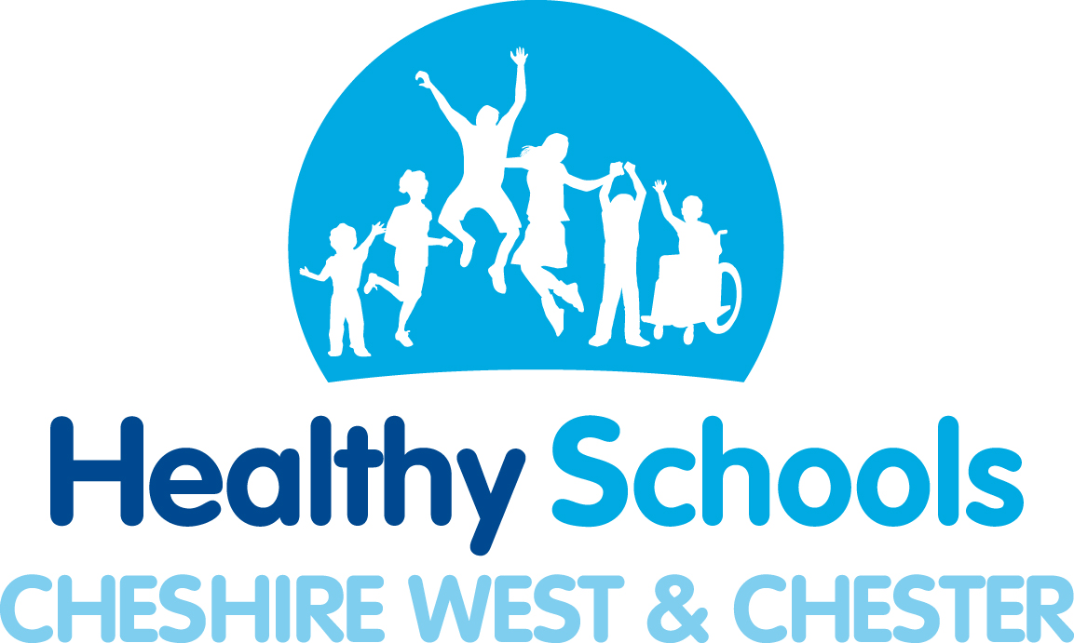
 |  | 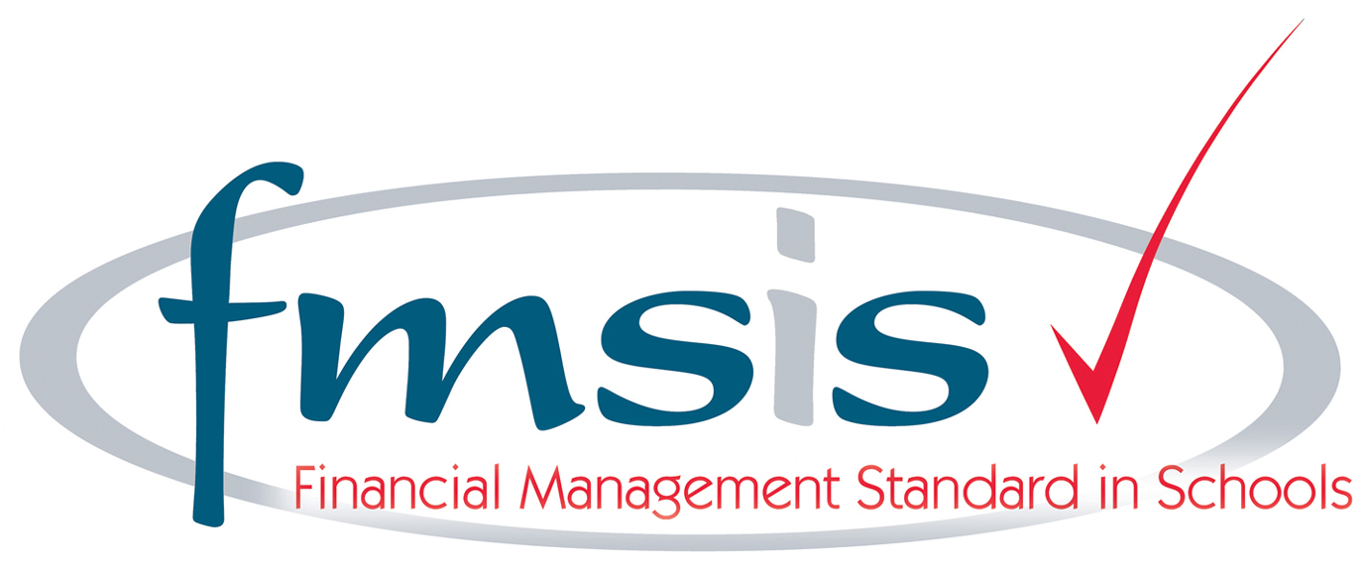 | 

